# C2- S5 - PRACTICE

*NOTE: check your* ***THEORY slides*** *to answer those questions!*

# EXERCISE 1 – GOOGLE CLASSROOM DATABASE

Here is the Entity Relation Diagram of the Google Classroom Database you designed in Chapter 1. You are now going to put it in MySQL!

**Q1 –** Write a statement to create the google classroom database, and to tell MySQL you are now working with it.

**Q2** – For each table (USER, USER_CLASSROOM, CLASSROOM, ASSIGNMENT, COMMENT),

complete the following arrays, by specifying for each attribute:

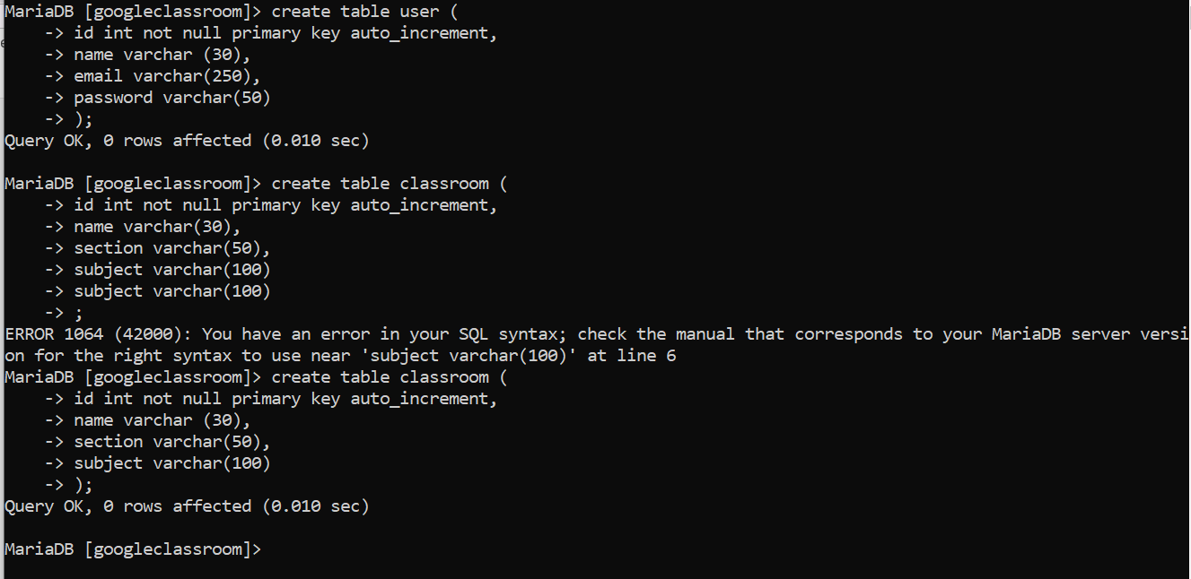

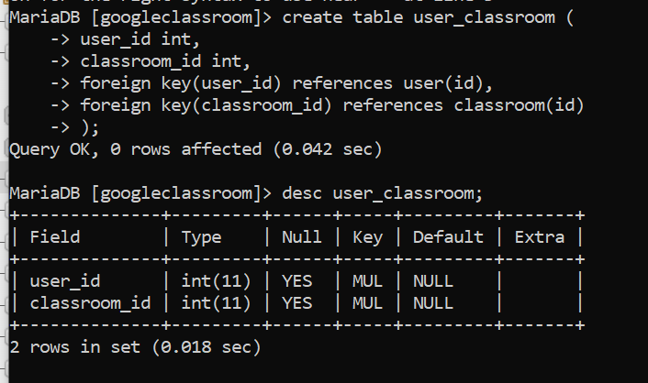

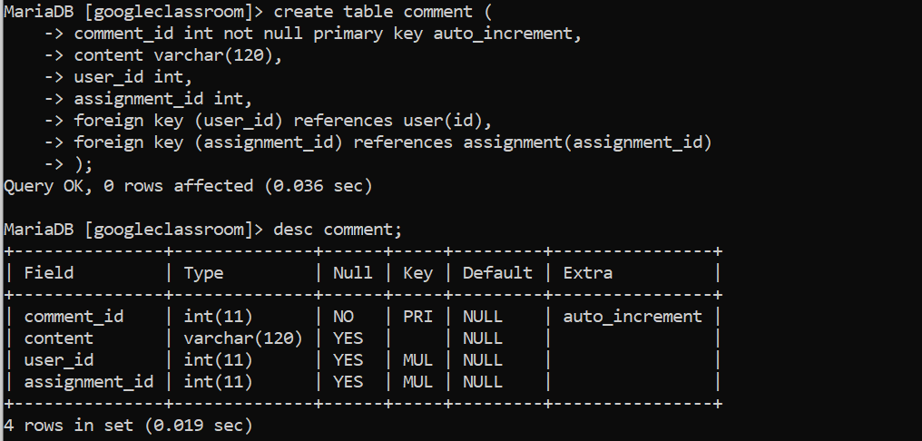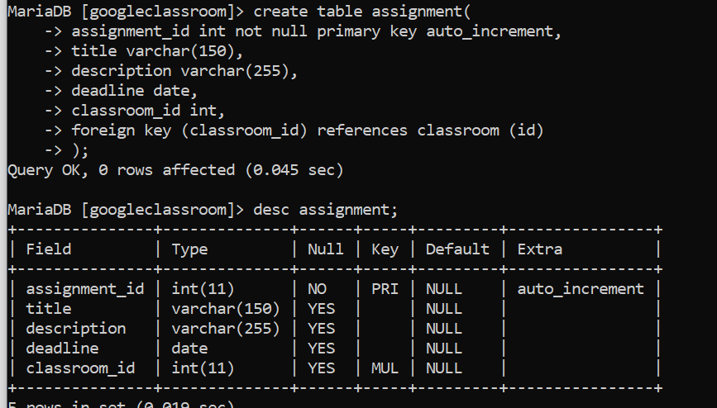

* + The attribute type (SQL type) and size
  + Can be null or not?
  + Is a primary key or foreign keys?
* **USER TABLE**

|  |  |  |  |
| --- | --- | --- | --- |
| Attribute name | Type / size | Can be Null? | Key |
| userId | int | No | PK |
| useremail | Varchar(120) | Can be null |  |
| Userpassword | Varchar (20) | Can be null |  |
| username | Varchar(15) | Can be null |  |

**USER_CLASSROOM TABLE**

|  |  |  |  |
| --- | --- | --- | --- |
| Attribute name | Type / size | Null? | Key |
| User Id | Int | No | FK |
| Classroom Id | Int | No | FK |
|  |  |  |  |

**CLASSROOM TABLE**

|  |  |  |  |
| --- | --- | --- | --- |
| Attribute name | Type / size | Null? | Key |
| Classroom Id | Int | No | PK |
| Name | Varchar(20) | Null |  |
| Section | Varchar(100) | Null |  |
| Subject | Varchar(50) | Null |  |

**ASSIGNMENT TABLE**

|  |  |  |  |
| --- | --- | --- | --- |
| Attribute name | Type / size | Null? | Key |
| Assignment Id | Int | No | PK |
| Title | Varchar(150) | Null |  |
| Description | Varchar(250) | Null |  |
| Deadline | Date | Null |  |
| Classroom Id | Int | No | FK |

**COMMENT TABLE**

|  |  |  |  |
| --- | --- | --- | --- |
| Attribute name | Type / size | Null? | Key |
| Comment_id | Int | No | PK |
| Comment | Varchar(50) | Null |  |
| User_id | Int | Null | FK |
| Classroom_id | Int | Null | FK |

**Q3** – Write the SQL statement to create the 5 tables with appropriate properties.

WARNING: Create the tables in the right order to respect the Foreign Key constraints.

**Q4 –** Write statements to insert at least 3 records in each table.

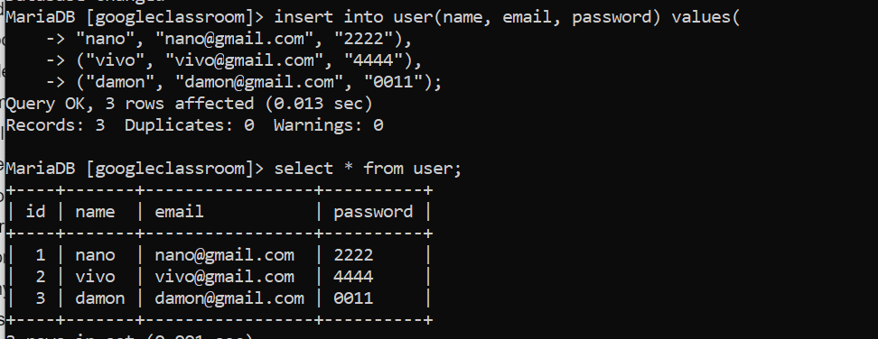

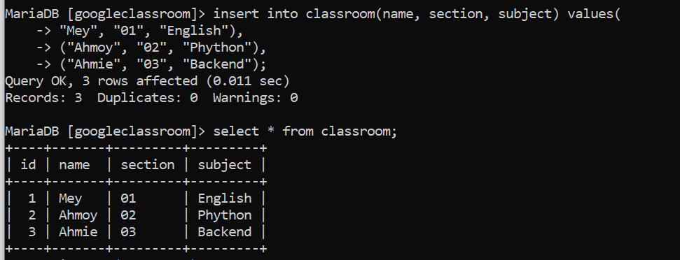

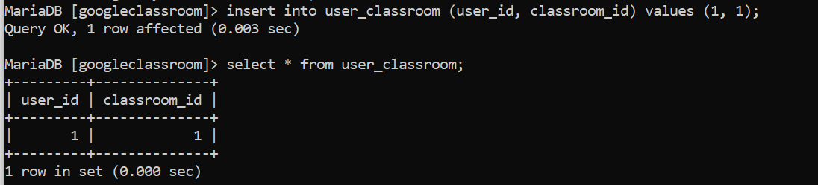

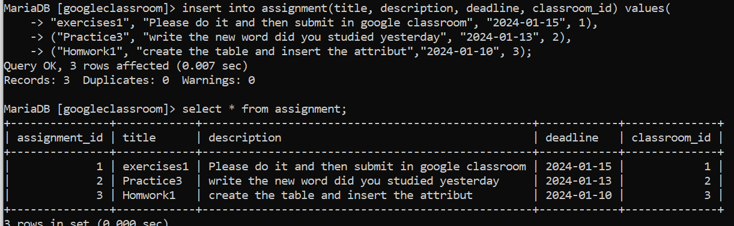

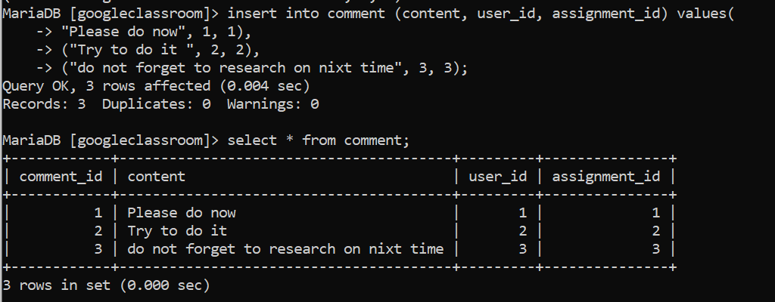

# EXERCISE 2 – FOODPANDA DATABASE

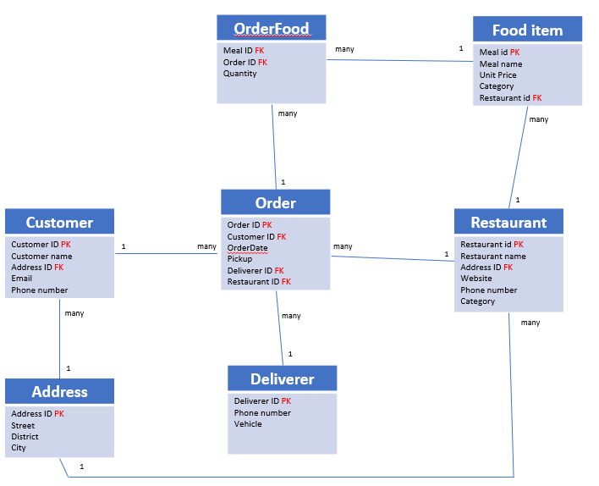

Here is the Entity Relation Diagram of the Foodpanda Database you designed in Chapter 1. You are now going to put it in MySQL!

**Q1 –** Write a statement to create the Foodpanda database, and to tell MySQL you are now working with it.

**Q2** – For each table of the database, complete the following array, by specifying for each attribute:

* + The attribute type (SQL type) and size
  + Can be null or not?
  + Is a primary key or foreign keys?

1. Address Table

|  |  |  |  |
| --- | --- | --- | --- |
| Attribute name | Type / size | Null? | Key |
| Address_id | Int | No | PK |
| Street | Varchar (12) | Null |  |
| District | Varchar(12) | Null |  |
| City | Varchar(50) | Null |  |

1. Customers Table

|  |  |  |  |
| --- | --- | --- | --- |
| Attribute name | Type / size | Null? | Key |
| Customers_id | Int | No | PK |
| Customers_name | Varchar(30) | Null |  |
| Address_id | Int | No | FK |
| email | Varchar(150) | Null |  |
| phonenumber | Varchar(10) | Null |  |

1. Deliverers Table:

|  |  |  |  |
| --- | --- | --- | --- |
| Attribute name | Type / size | Null? | Key |
| Deliver_id | Int | No | PK |
| Phonenumber | Varchar (13) | Null |  |
| Vehicle | Varchar(30) | Null |  |

1. Restaurants Table:

|  |  |  |  |
| --- | --- | --- | --- |
| Attribute name | Type / size | Null? | Key |
| Restaurants_id | Int | No | PK |
| Restaurant name | Varchar (30) | Null |  |
| Address_id | Int | No | FK |
| Website | Varchar (150) | Null |  |
| Phone number | Varchar(13) | Null |  |
| category | Varchar(50) | Null |  |

1. Food_items Table:

|  |  |  |  |
| --- | --- | --- | --- |
| Attribute name | Type / size | Null? | Key |
| Meal_id | Int | No | PK |
| Meal name | Varchar(30) | Null |  |
| Unit price | Varchar(30) | Null |  |
| Category | Varchar (50) | Null |  |
| Restaurant_id | Int | No | FK |

1. Orders Table:

|  |  |  |  |
| --- | --- | --- | --- |
| Attribute name | Type / size | Null? | Key |
| Order_id | Int | NO | PK |
| Customer_id | Int | No | FK |
| Order_date | Date | Null |  |
| Delivery_id | Int | Null | FK |
| Restaurant_id | Int | Null | FK |

1. Order_food Table:

|  |  |  |  |
| --- | --- | --- | --- |
| Attribute name | Type / size | Null? | Key |
| Meal_id | Int | No | FK |
| Order_id | Int | No | FK |
| Quantity | Varchar (50) | Null |  |

**Q3** – Write the SQL statement to create the tables with appropriate properties.

WARNING: Create the tables in the right order to respect the Foreign Key constraints.

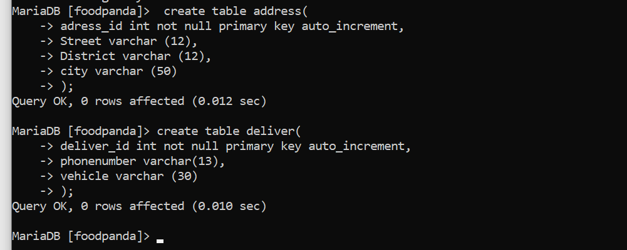

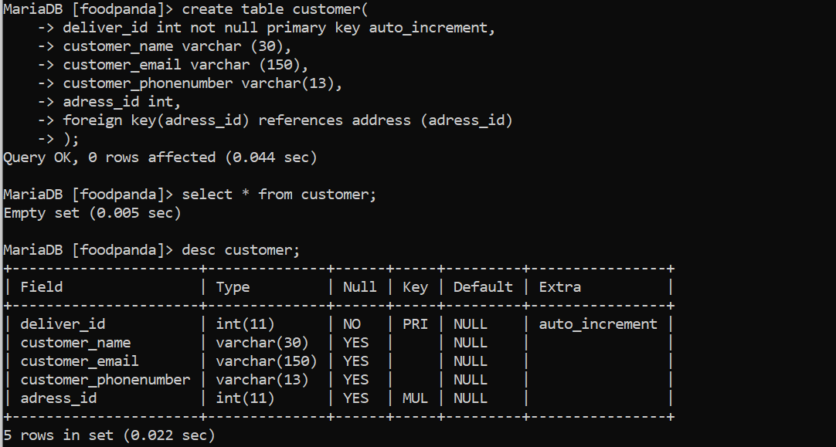

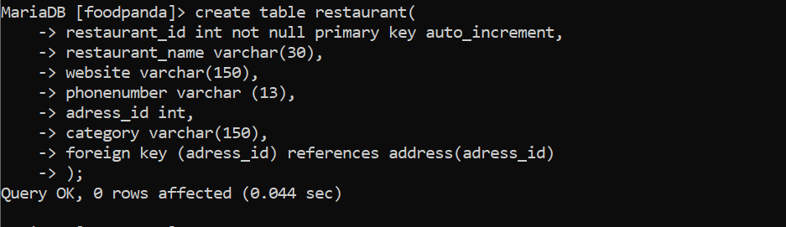

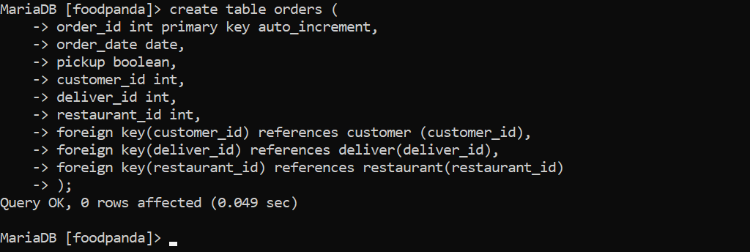

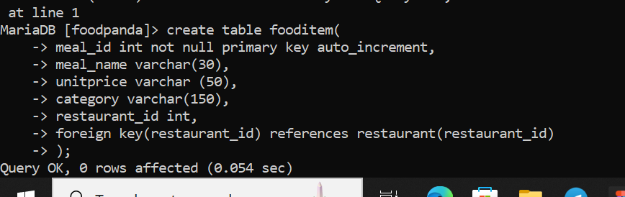

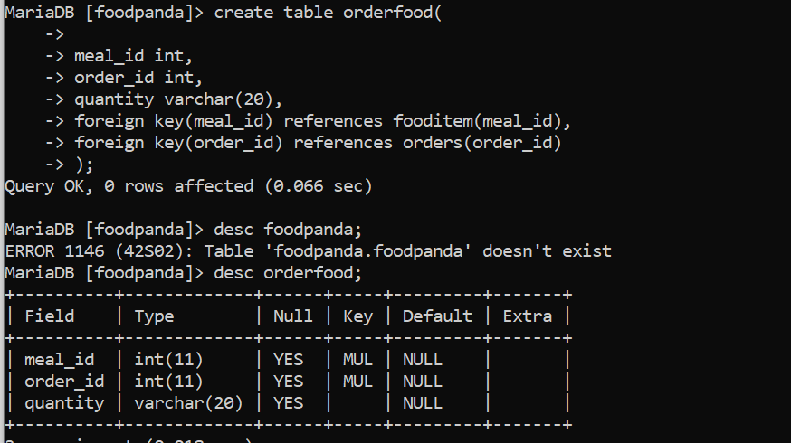

**Q4 –** Write statements to insert between 2 and 4 records in each table.